Andrew Wray, Presentation to Staff, LE#2, Et#9.
TECHNOLOGY & THE SPECIAL EDUCATION LEARNER
A Support Document for New Teachers
Contents
Introduction 2
Tips for Integration 2
1. Learner Profiles 2
2. Familiarity with Technology 2
3. Free Exploration 3
4. Goals, Expectations, & Outcomes 3
5. Break the Task in to Parts 3
6. Be Flexible 3
7. Integrate for All 4
8. Learning Styles 4
9. Support Staff 4
10. Individual Education Plans (IEPs) 4
11. Location 4
12. Attitude 4
Programs 5
Clicker 5.28 5
Overview 5
Applications 5
Professional Reading 6
Links for Support 6
Frames 5 7
Overview 7
Applications 8
Professional Reading 8
Links for Support 9
Resources 9
Bibliography 10
Appendix A 11
Appendix B 14
Appendix C 21
Appendix D 23

Technology & the special education learner

Introduction
Technology can be an excellent tool for special education learners. There are many different learners and many different technologies. One of the roles of a teacher is to correctly match the technology to the learner. You first have to know your students and what makes them tick. Only then can you accurately match and integrate the technology for him/her. In this manual, you will find tips, hints, suggestions, lesson plans, assessments, and various resources for which you can utilize to teach special education students, using technology and Web 2.0 software.

Tips for Integration
The following is a list of key areas for you to consider when beginning to integrate assistive technology in to your classroom.

Learner Profiles
Knowing your student(s) is the ultimate key to selecting an appropriate technology for them. Some things you must keep in mind are:
- Age of your student
- Learning style (i.e., visual, auditory, kinesthetic, tactile, musical, logical, verbal)
- Interests/likes as well as dislikes
- Intellectual profile (e.g., academic achievement & psychological assessments)
- Areas of need and/or development (i.e., motor skills, organization, social skills)
- Diagnosis(es)
- Individual Education Plans (IEPs)

Familiarity with Technology
Special education students have a variety of abilities and difficulties. When you are familiar with the ins-and-outs of the technology you wish to use, then you give your special education learners an excellent chance to be successful in its use.
Here’s a tip:
- Try to approach the technology or software from the students’ perspective, especially the special education students. Ask yourself the following:
    - What features might they have difficulty using?
    - Are the toolbars easy to use?
    - Is the interface accessible and clearly labelled?
    - Is the digital workspace easy to manipulate?

Free Exploration
Before delving too far in to the task for which you want your students to complete, set aside some time for all students to explore the software and/or technology. You may want to give students some guidance by showing them a few features and then allowing them to continue to explore on their own, or you can simply let them go. The purpose of the task is to make the student’s learning personal. You may be surprised at how much they know.

Goals, Expectations, & Outcomes
In order to best prepare special education students for your unit of study, assessment, or culminating assignment, you should have a clear and precise goal, which should be made clear to all your students. This will allow your special education students an opportunity to absorb the information, skills, and applications. The expectations and outcomes for the task should also be made aware to all students. Success criteria, checklists, rubrics, mini-lessons, and assignments should all be outlined at the beginning of the unit, so that any difficulties, anxieties, or questions can be alleviated, and any adaptations or accommodations can be made before there is too much work completed on the task.
Also, the final assignment for your special needs students may look different than the other students. The accommodations, modifications, and adaptations should be established before the students begin on their assignment(s).

Break the Task in to Parts
Longer tasks such as essay writing or dramatic performances involve many steps. Your special education students may not be able to plan, write, revise, re-revise, edit, and publish without much support. To help ease the students’ dependence, you should break the task in to smaller parts.
For example, you may want to have your students create a persuasive piece which includes some type of media. To let your students collaborate and create on their own might end up in disaster. But, if you broke the task in to simpler tasks, then your special education students who struggle with executive skills would fare much better.

Be Flexible
If you plan on having your students produce the same product, then you may be prohibiting your special education students. As mentioned earlier, your students have a wealth of strengths and interests. For some, these topics and abilities are strong motivators which allow them to be successful. Providing your students with technology is one way you can help him/her develop as readers and writers, and permitting them some ownership in their learning can go a long way.

Integrate for All
Sometimes, special needs students feel stigmatized by the technology in which they are provided. They feel it makes them different. Instead of simply integrating it for the special education students, try developing lessons and units for al to make use of the technology. This will, hopefully, alleviate some of the stigma.

Learning Styles
When selecting a software program or Web 2.0 tool, you should keep in mind that your special education students have areas of great strength as well as areas of difficulty. These areas of strength can be your best resource when working with special needs students. Knowing your students’ preferred learning style(s) is a great way to ensure that the programs you are integrating will meet your students’ needs. Try to select a program that encapsulates a variety of learning styles and at the same time does not require a lot of new learning on behalf of the student (i.e., unfamiliar interface, unnecessary features, many distractive options).

Support Staff
Make sure you connect with your Special Education Resource Teacher(s) (SERT). He/She will be able to guide you through the process of integrating technology and may be able to make suggestions to you for types of technology that would most benefit your students. Another person capable of aiding you would be your principal. He/She is the educational leader in your school and can connect you with the right people to make your transition easier.

Individual Education Plans (IEPs)
To meet the needs of your special education students, you must be aware of the expectations, accommodations, and modifications outlined in the student’s IEP. For some students, it is necessary that they use a specific type of assistive technology, especially if recommended by a physician. Be aware of the information in your students’ IEPs, so that you are providing the necessary resources for them. You may also find that there are some good tools recommended for all your students to utilize.

Location
One aspect new teachers often overlook is where his/her students are going to access the technology and/or software programs. In some schools, mobile labs are frequently used by teachers. In others, the computer lab is the ideal location. And, still others have computers available in the classroom itself. But not all types of technology can be effectively used in all environments. When deciding on a type of technology, you should spend some time considering the location, so that you are meeting all the needs of your special education students.

Attitude
Maybe the most important aspect of integrating technology in to your classroom may be yourself. Your attitude towards the application and purpose of the chosen technology will be the reason why your students succeed and enjoy the process of learning. Remember: you are ‘techspert’.

Programs
The following programs are excellent resources to use and integrate in to your classroom programming for students with special needs in which to make use. The programs and software can also be used for all students in your classroom, not just the special needs.

Clicker 5.28

Overview
This is a multimedia tool that enables children to:
- Write using words, phrases, and pictures
- Type words or phrases with a keyboard
- Select words, phrases, or pictures from the Clicker dictionary and/or library and paste them in to their work
- Hear a pre-recording of the words they select
- Record their own speech
- Store all their videos, sounds, pictures, and written documents, making it easy to share
This software supports students with:
- Dyslexia
- Learning disabilities in the academic subject areas of reading, writing, and oral language development
- Speech and language impairments
- Physical disabilities

Applications

Lesson Ideas:
Lesson #1: KWL Chart (SEE APPENDIX A FOR FULL LESSON PLAN)
Grades 3-8
Introduction
This lesson will provide the necessary skills for using the tools to populate a KWL chart and allow the students an opportunity to share what they know, what they want to learn and finally what they learned about a topic.
Learning Objectives
Upon completion of this lesson, using the Clicker 5 KWL chart:
- students will brainstorm what they know about a given topic
- students will brainstorm what they want to find out about a topic
- students will brainstorm what they learned about a topic

Lesson #2: Creating a Talking Book (SEE APPENDIX B FOR FULL LESSON PLAN)
Grades 3-8
Introduction
Students with special needs often struggle with the writing process making it challenging for them to show what they know. Using the Bookmaking templates and writing supports in Clicker 5, along with some simple tips for creating a talking book, students can demonstrate what they know in a variety of ways and overcome many of the barriers that have previously prevented them from writing.
This is the final lesson in this set of Clicker 5 whole class activities. The students end the unit by demonstrating what they have learned by creating a book using Clicker 5.
This lesson will provide the necessary skills for creating a talking book with guided support and allow the student(s) an opportunity to share what they know and have learned about a topic.
Learning Objectives
Upon completion of this lesson:
- students will independently create a ‘Talking Book’ to show what they know about a topic of study

Professional Reading
- Parette, H.; Hourcade J.; Dinelli, J.; & Boeckmann, N. “Using Clicker 5 to Enhance Emergent Literacy in Young Learners” Early Childhood Education Journal. February, 2009, Volume 36, Issue 4, pp- 355-363.
- Parette, H.; Boeckmann, N.; Hourcade, J. “Use of Writing with Symbols 2000 Software to Facilitate Emergent Literacy Development” Early Childhood Education Journal. October, 2008, Volume 36, Issue 2, pp. 161-170.

Links for Support
- http://www.cricksoft.com/us/home.aspx
Crick Software LearningGrids has a large selection of free, ready-made materials for users of Clicker to incorporate in to their programming.

- http://www.setbc.org/setbc/curriculum/clickguidelearn.html
Special Education Technology: British Columbia: The Learning Centre is a great resource for teachers looking to integrate Clicker software in to their programming. There are a lot of tools, resources, tutorials, videos, and documents available for visitors to utilize.
- http://www.youtube.com/watch?v=nk49NJmpD38&list=PLE0503242FC033923
This YouTube channel will provide you with all the necessary training you will require to utilize Clicker 5 in your classroom. There are 22 videos focusing on all aspects of the program from building grids to designing lesson plans to meet the needs of your individual students.
- www.cricksoft.com/uk/blog.aspx
This is a United Kingdom webpage that features many tips, hints, updates, as well as some technical advice and support for the latest Clicker 6 software. It also provides support for previous versions.

Frames 5

Overview
This is an award winning stop-motion animation, Claymation, and digital storytelling software. Frames 5 allows users to delve in to the world of directing, animating, and even graphic novels. Users can utilize the pre-installed designs, pictures, and audio to create their own video footage, or they can develop their own and import and upload it to the program. Any footage the user uploads can be saved in the Frames 5 library and accessed each time he/she opens the software. Developing a movie, video, Claymation, or animated movie is as simple as dragging and dropping.
This is a multimedia tool that enables children to:
- Collaborate with their peers on a shared project
- Develop self-expression by utilizing the easy to use features
- Share their creations with a large audience via the Internet
- Publish multimedia works for a variety of purposes
- Record their own voice and video footage, capture their own images, and create their animated characters
- Playback and revise work completed previously
This software supports students with:
- Fine and gross motor difficulties
- Speech and language as well as visual impairments
- Learning disabilities such as auditory processing difficulties
- A variety of learning styles

Applications

Lesson Ideas:
Lesson #1: Create a Video Poem (SEE APPENDIX C FOR FULL LESSON PLAN)
Grades 4-8
Introduction
The National Poetry Council is looking for ways to promote interest in poetry. Since most homes have a television, they have decided to broadcast short poems set to music and pictures. They have asked for help to build their collection.
Learning Objectives
- Collaborate with peers on a shared project
- Apply features of a multimedia software program to create a unique piece of work
- Infer messages in artistic texts
- Identify implied messages used by authors through the use of voice, tone, word choice

Lesson #2: Fantastic Fractions (SEE APPENDIX D FOR FULL LESSON PLAN)
Grades 2-6
Introduction
After seeing Wallace & Gromit, or other clay-animated film, the people at your local public access television station think it might be a good idea to add clay animation to their animated short films that play on Saturday mornings. They want to see some samples before they make their decision. To help them, you will create a sample clay animation that teaches kids about fractions.
Learning objectives
- Demonstrate creative thinking and develop innovative products and processes using technology
- Use digital media to communicate and work collaboratively
- Understand that a fraction is part of a whole and is relative to the entire whole
- Understand that a fraction is a number on a number line

Professional Reading
- “Using Claymation to Engage the Multiple Intelligences” (n.d.)
http://www.tech4learning.com/userfiles/file/pdfs/Clay/clay_multiple_intelligences.pdf.
- Hoban, Garry F. “From Claymation to slowmation: a teaching procedure to develop students’ science understandings” Teaching Science. Winter, 2005, Volume 51, Issue 2, p. 26.
- Mills, Kathy. “Multiliteracies and a Metalanguage for the Moving Image” Proceedings. 2008. Retrieved from http://eprints.qut.edu.au/14967/1/14967.pdf.

Links for Support
- http://www.tech4learning.com/frames
This is the software’s creator’s website. It contains tutorials, tips, hints, and lesson ideas for the software. It also provides video footage of the software being used in a classroom setting.
- http://web.tech4learning.com/
This blog is a great way to stay on top of the most recent developments in digital storytelling integrated in the classroom. It has some great articles and links for a variety of types of software.
- http://www.youtube.com/watch?v=TiQlSsJcy-U
This YouTube video provides a good overview of the software and its capabilities. It would make a good ‘hook’ for students at the beginning of a unit of study or culminating assignment.

Resources
In this section, you will find some specific and some general resources for integrating technology in your classroom.
- http://www.slideshare.net/kmott/integrating-technology-in-a-special-education-classroom
This presentation demonstrates how a teacher integrates technology in her classroom for all her students’ benefit. There are some examples of assistive technology she uses to help her special needs students as well as some software programs she uses as accommodations.
- http://www.youtube.com/watch?v=678wQkin_fY
This is an excellent video for teachers new to integrating technology in their classroom. It outlines programs, software, web tools, as well as tips for integrating technology.
- http://www.youtube.com/watch?v=mzi2RIt8_nk
This video outlines 10 reasons why technology should be integrated in to every classroom.
- http://www.usask.ca/education/coursework/802papers/antifaiff/antifaiff.htm
This article expertly outlines reasons why teachers should integrate technology in to their classrooms. It also provides tips, hints, and guidelines for integrating technology.

Bibliography
- Antifaiff, Gloria. (April, 2000) Integrating Technology into the Curriculum. Educational Communications and Technology. Retrieved February 15th, 2013, from
http://www.usask.ca/education/coursework/802papers/antifaiff/antifaiff.htm.

- OSAPAC (2008) Resources. ”Frames 5”. Retrieved February 15th, 2013, from
http://www.osapac.org/db/view_software.php?id=485.

- OSAPAC (2008) Resources. ”Clicker 5.28”. Retrieved February 15th, 2013, from
http://www.osapac.org/db/view_software.php?id=465.

- Special Education Technology-British Columbia (2011). “KWL Chart”. The Learning Centre. Retrieved February 15th, 2013, from
http://www.setbc.org/setbc/curriculum/clickguidelearn.html.

- Special Education Technology-British Columbia (2011). “Talking Book”. The Learning Centre. Retrieved February 15th, 2013, from
http://www.setbc.org/Download/LearningCentre/curriculum/7_TalkingBook_New.pdf.

- Tech4Learning (n.d.) Create a Video Poem. In Creative Educators. Retrieved February 15th, 2013, from http://creativeeducator.tech4learning.com/v02/lessons/Create_a_Video_Poem.

- Tech4Learning (n.d.) Fantastic Fractions. In Creative Educators. Retrieved February 15th, 2013, from
http://creativeeducator.tech4learning.com/v04/lessons/Fantastic_Fractions.

Appendix A

Clicker 5 (Windows)

Lesson 1: KWL

Introduction
A KWL Chart is a graphic organizer widely used as an instructional technique for activating a student’s prior knowledge, and setting a purpose for reading. This organizer helps to focus students’ attention to key ideas about a topic; as well as help students demonstrate what they know, what they want to learn and what they learned from a topic.
The Clicker 5 format KWL chart has been set up with 3 text boxes on one page. The text boxes are blank and can be populated quickly by the teacher as the students brainstorm what they know, what they want to know and once the unit is complete, what they learned about the topic being studied.

This lesson will provide the necessary skills for using the tools to populate a KWL chart and allow the students an opportunity to share what they know, what they want to learn and finally what they learned about a topic.

Learning Objectives

Upon completion of this lesson, using the Clicker 5 KWL chart:

- students will brainstorm what they know about a given topic
- students will brainstorm what they want to find out about a topic
- students will brainstorm what they learned about a topic

Materials and Resources

- Clicker 5
- Clicker 5 unit (e.g. Maps_Unit.clkx).

Teacher Preparation

- Determine the Windows computer to be used during the lesson, and ensure Clicker 5 is installed.
- Set up projection system to project Clicker 5 activity.
- Save the Clicker 5 unit that will be used during the lesson to the computer (e.g. Maps_Unit.clkx)

Completing the KWL Chart
1 | The KWL brainstorming activity can be  carried out as a large group, or independently by the students as appropriate.  To complete this activity, first open the appropriate Clicker 5 unit (e.g.  Maps_Unit.clkx). The unit will open at a home screen with buttons linking to each of the unit lessons.  For this lesson you will be working with the “KWL” activity.  To open the activity.  • Click the KWL button. | 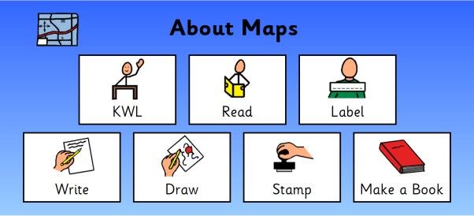  Click  KWL
2 | As a group, brainstorm information related to the topic. As ideas are generated, add information to the KWL chart (What I know, what I want to learn and once the unit is completed, what I learned).  To add text to the KWL chart:  - Hold Shift, and Left-Click into each text box  - Type into the open text field | 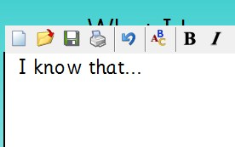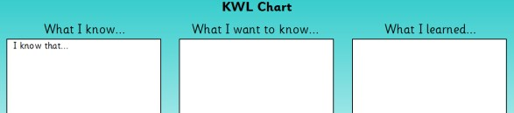  Shift  -  L  e  f  t  -  Click  into  text boxes.

3 | When the unit is complete (lessons 2-7) the class should revisit the KWL chart to complete ‘what I learned’ in the last cell  To add text.  • Hold Shift and Left-Click into the What I Learned text box | 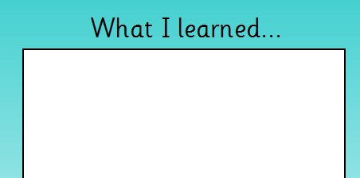  Shift  -  L  e  f  t  -  Click  into  text boxes.

Appendix B

Clicker 5 (Windows)
Lesson 7: Creating a Talking Book

Introduction

Students with special needs often struggle with the writing process making it challenging for them to show what they know. Using the Bookmaking templates and writing supports in Clicker 5, along with some simple tips for creating a talking book, students can demonstrate what they know in a variety of ways and overcome many of the barriers that have previously prevented them from writing.
This is the final lesson in this set of Clicker 5 whole class activities. The students end the unit by demonstrating what they have learned by creating a book using Clicker 5.
This lesson will provide the necessary skills for creating a talking book with guided support and allow the student(s) an opportunity to share what they know and have learned about a topic.
Learning Objectives

Upon completion of this lesson:
- students will independently create a ‘Talking Book’ to show what they know about a topic
Materials and Resources

- Clicker 5
- Clicker 5 unit (e.g. Maps_Unit.clkx)

Teacher Preparation

- Determine the Windows computer to be used during the lesson, and ensure Clicker 5 is installed.
- Set up projection system to project Clicker 5 activity.
- Save the Clicker 5 unit that will be used during the lesson to your computer desktop (e.g. Maps_Unit.clkx).

Student Guided Practice

Making a Clicker 5 Talking Book
1 | To complete this final activity, first open the appropriate Clicker 5 unit (e.g. Maps_Unit.clkx) from “Clicker 5 Units” on the Learning Centre web page. The unit will open at a home screen with the buttons linking to each of the unit lessons. | 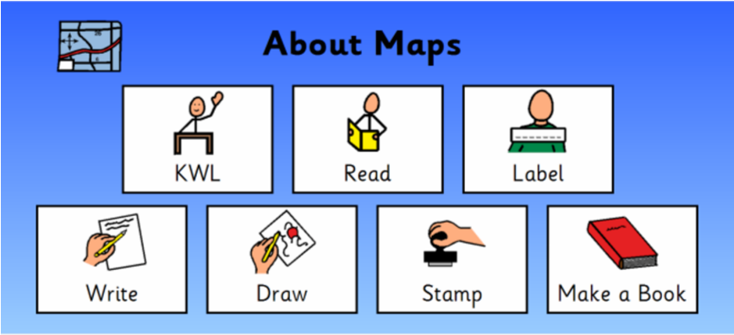
 | For this lesson you will be working with the “Read” activity.  To open the activity.  • Click the Make a Book button | Click Make a Book
2 | In this lesson the students will build a book related to the unit topic. To ensure the students don’t lose their work, have them begin by creating a title and saving their book. Demonstrate saving Clicker 5 Books to the class:  To save the books.  • Select File and then Save Gridset As  A dialog box will appear.  - Click and type into the text field to give the book a descriptive title  - Click the Save button  Note: encourage the students to save often to ensure that no one loses their work. | 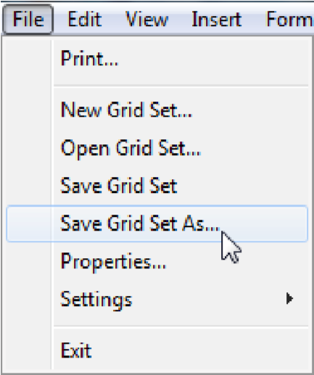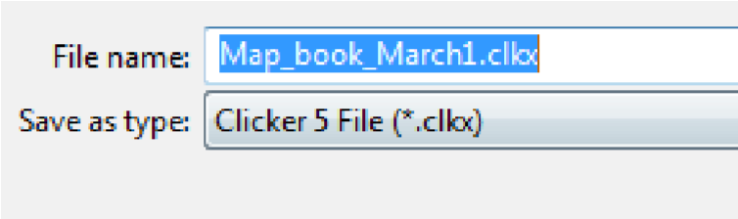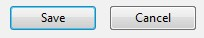  Click  Save  Grid  S  et As  Type  title  Click  Save
3 | The size of the Clicker 5 window will need to be adjusted so that images and sounds can be dragged to the Clicker 5 cells. Demonstrate re-sizing the window to the class.  To re-size the window.  • Click the Restore Down icon to make the Bookmaking Template smaller | Click  to  Restore  Down
4 | A folder of pictures has been provided for the students to use as they create their books. Demonstrate opening, and viewing these folders.  To open the folders.  - Double-Click the folder of sounds and images to view  - Click and Drag to scroll around the folder | Double  -  Click  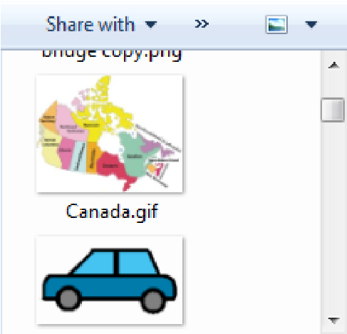  Click  and  Drag  to  s  croll  images
5 | You may want to adjust the folder icon view to see the full image preview.  To adjust the image view.  • Click the drop down arrow beside the Change your View icon | 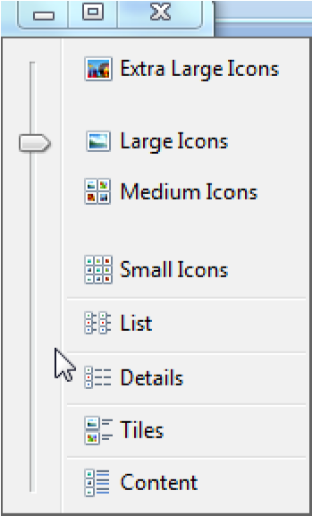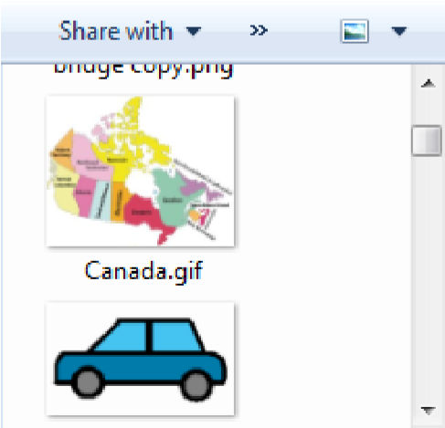  Click  to  select  large  or  medium  icons  Click  to see  icon view  options
6 | The students will need to adjust the size of the folder so that images and sounds can be dragged to the Clicker 5 cells.  Demonstrate re-sizing this folder.  To re-size the folder  - Click on Restore Down to make the folder of sounds or pictures smaller  - Click and drag from the bottom right corner to size the window | 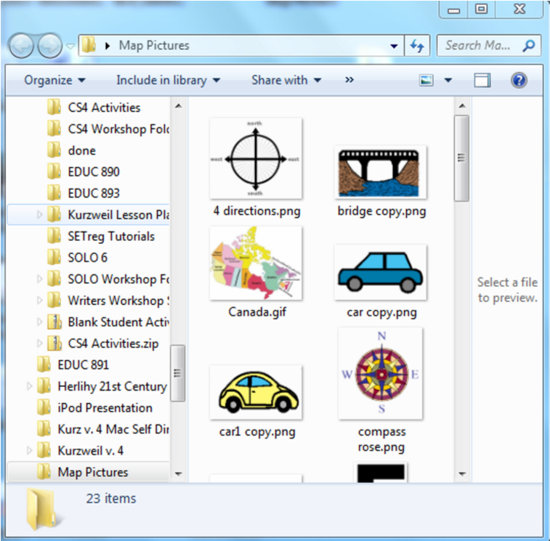  Click  to  Restore  Down  Click  and  Drag  to  resize
7 | Now that you have re-sized both the windows you will need to arrange the  Bookmaking Template and  Images/Picture Folders side by side.  Demonstrate this to the class.  To arrange the two windows.  • Click and Drag from the window title bars to move the windows side by side | 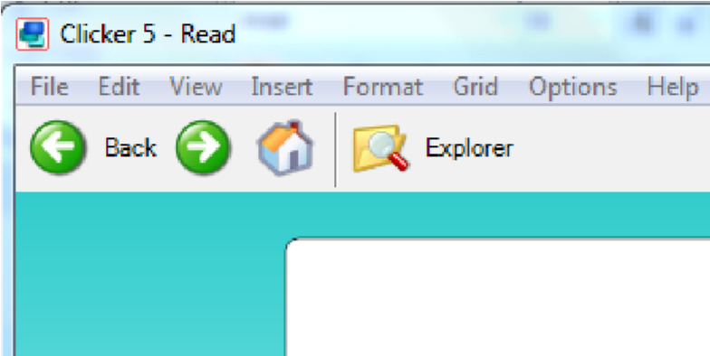  Click  and  Drag  to move  window
8 | Pictures can be dropped directly into Clicker 5 cells if you have allowed for this in the Clicker 5 preferences (see preparation tutorial “Setting Clicker 5 Preferences”). Demonstrate this to the students.  To add an image to a cell.  • Drag and drop an image from the Folder of images/sounds to the desired Clicker 5 cell | 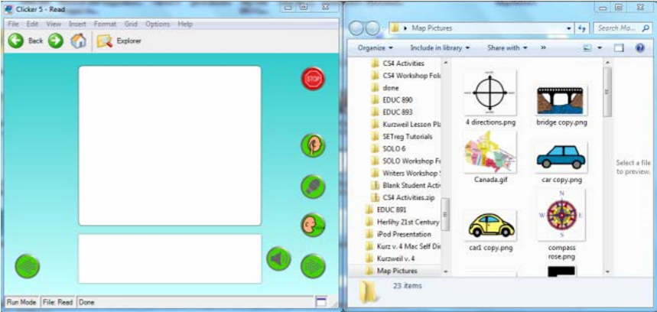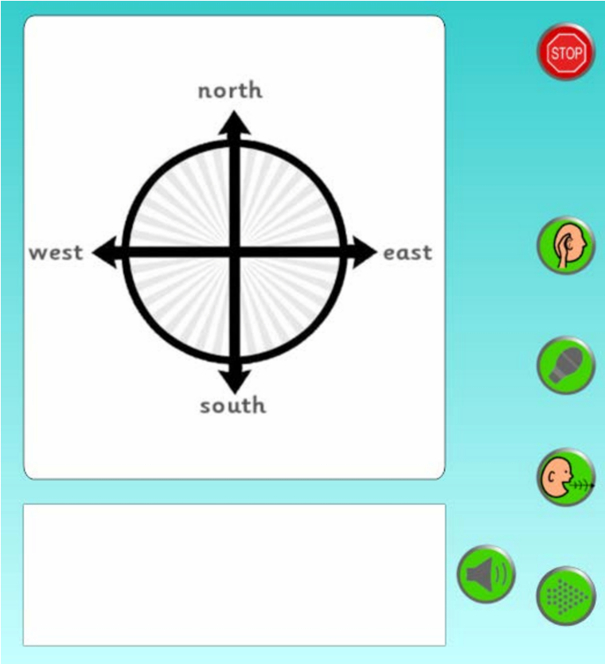  Click  and  Drag  images  to  Cell
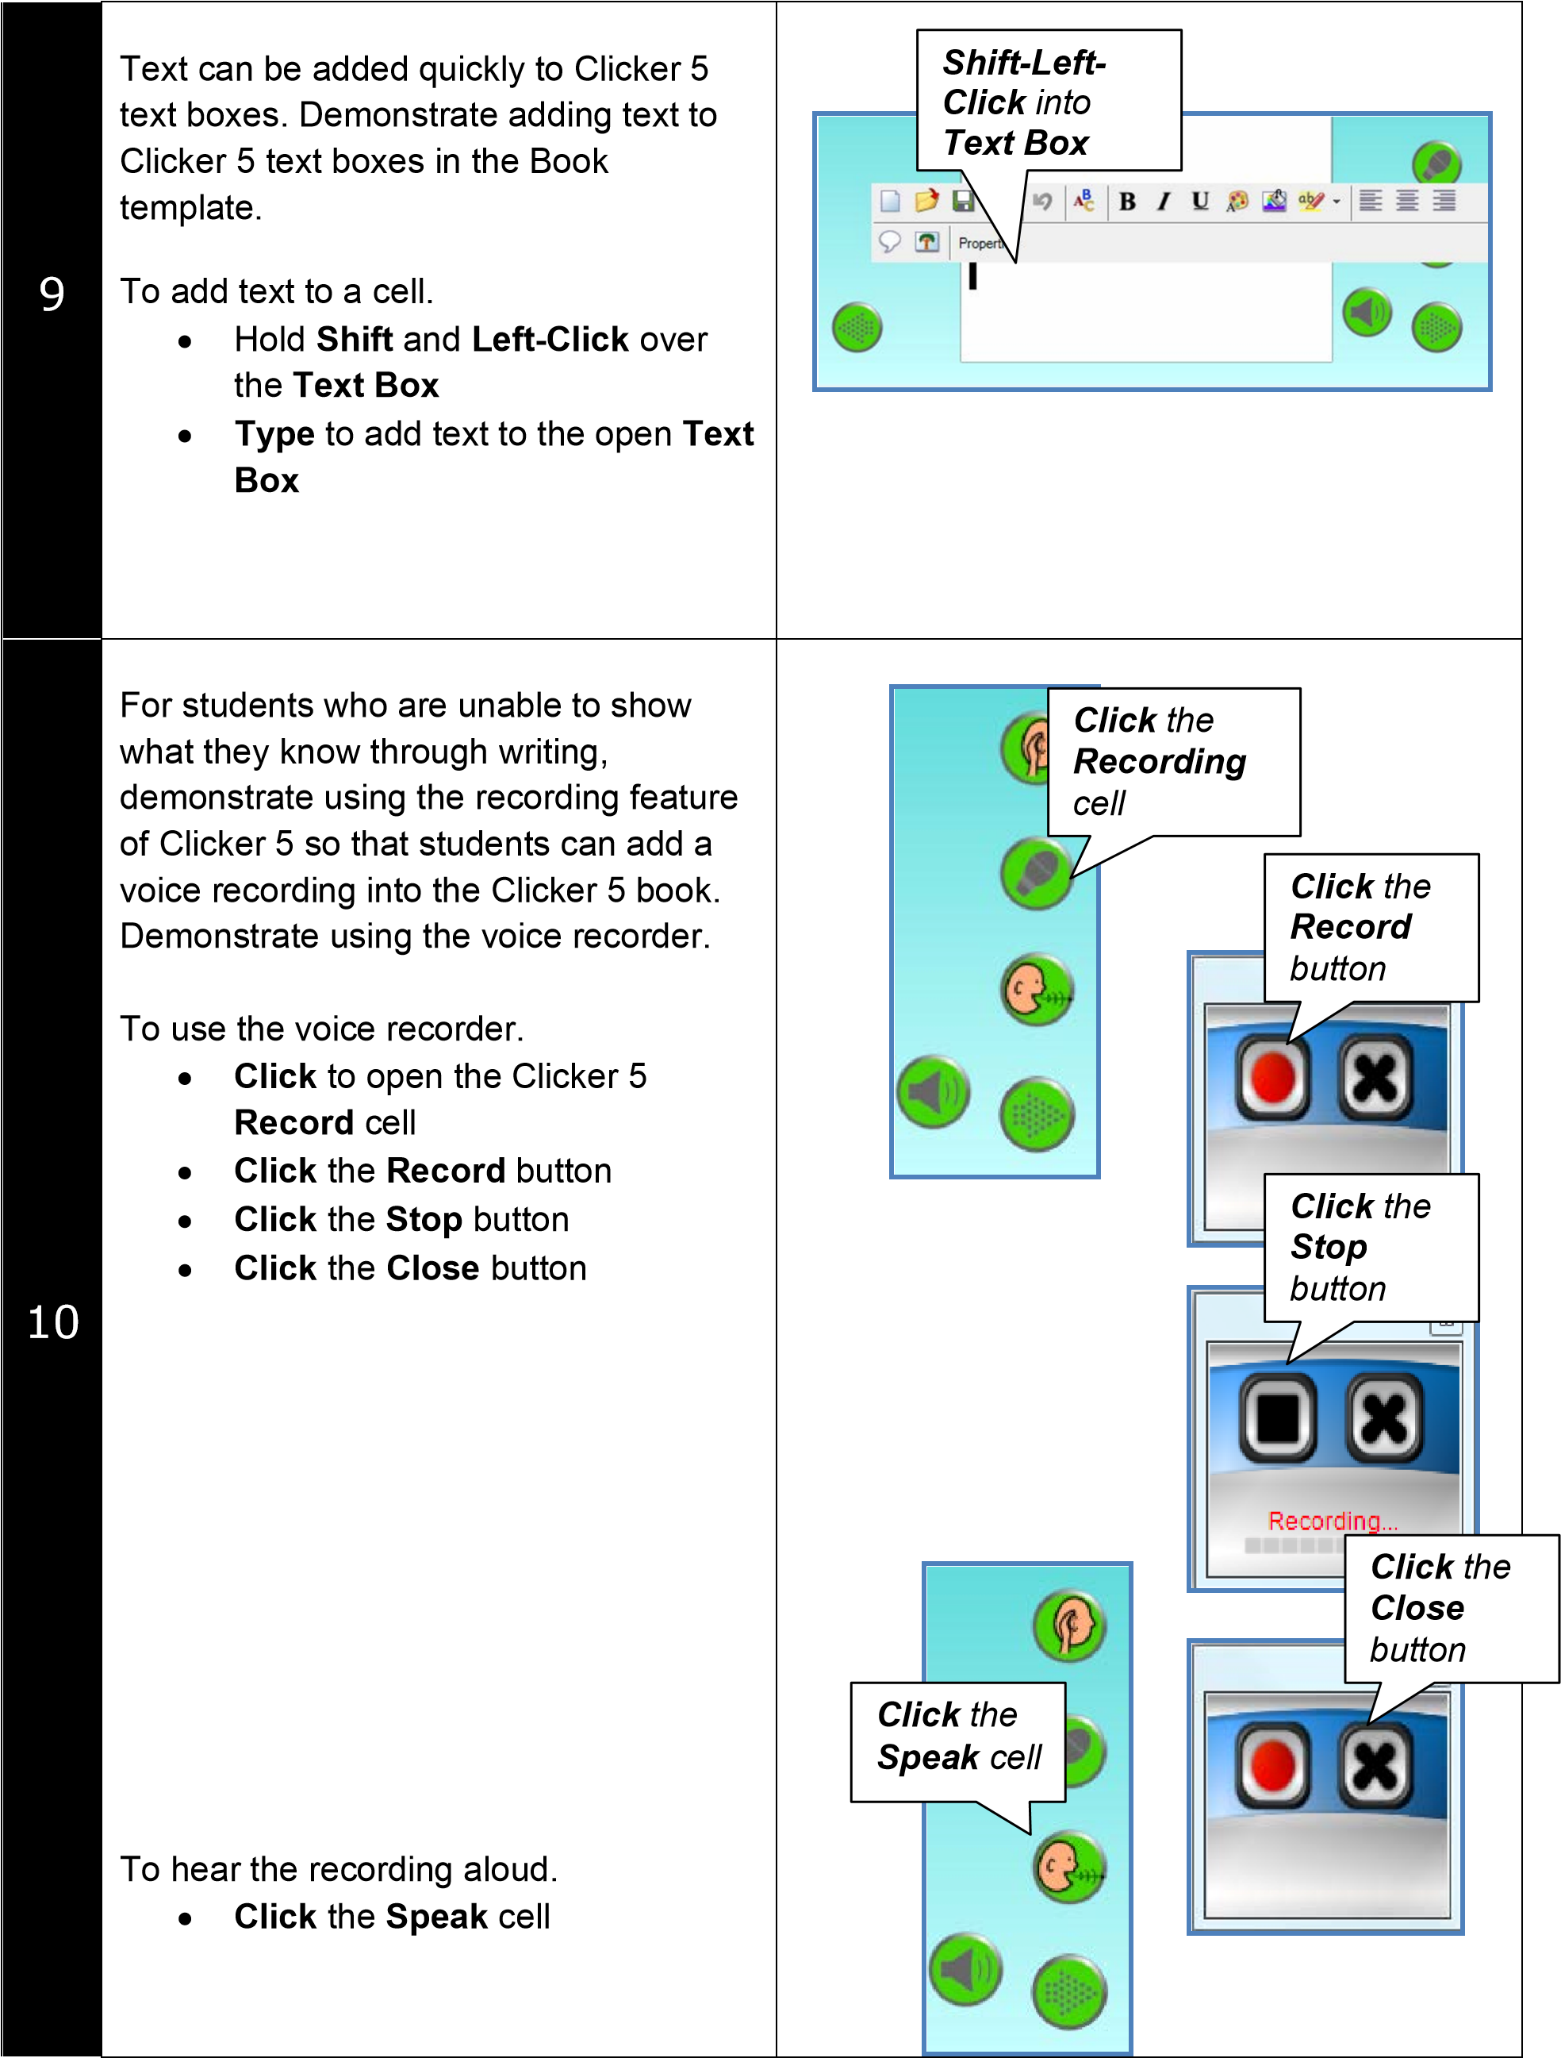
11 | As the students fill images, sounds, and recordings they will need to continuously move forward through the book. Demonstrate using the page navigation cells to move forwards through the book.  To move to the next page.  • Click the Next Page cell to navigate to the next page.  Repeat the above process until the book is complete. | 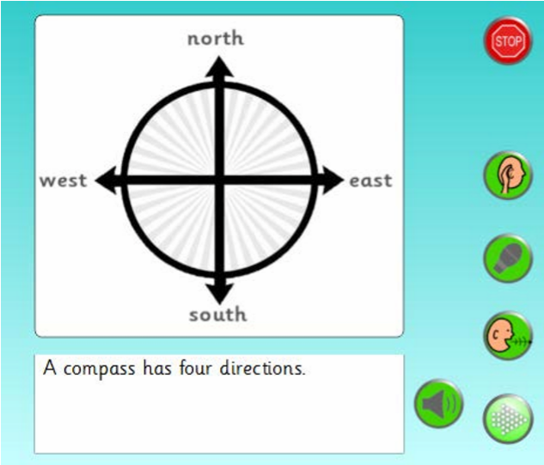  Click  the  Next Page  cell
12 | As the students complete their books have them edit their books. Demonstrate navigating back and forth through the book listening to the sounds, recordings, and text boxes to self correct for errors.  To move through the book while selfcorrecting.  - Use the Sound or Speak Text  cells to listen to the story  - Use the Back arrow to re-read a page  - Use the Stop button to return to the beginning of the book. | 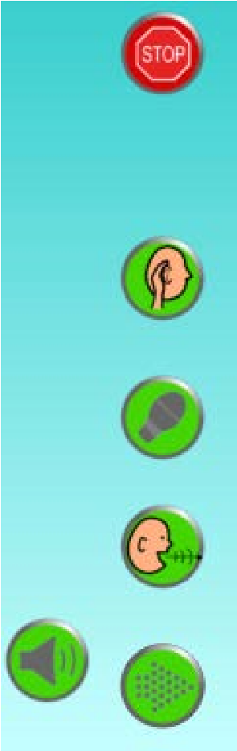  Sound  cell  Speak  Text  Back  Stop

Appendix C
Identifiers
Grade Level
4-12
Subject
Language Arts
Duration
1 week
Objective
Students will create a video poem as they analyze the imagery in the text.
Description
Students will analyze a poem by breaking it into scenes. The text for each scene will be supported by appropriate images and sounds. They will use Frames to create their video poem.
Application
Frames™, Pics4Learning
Introduction
The National Poetry Council is looking for ways to promote interest in poetry. Since most homes have a television, they have decided to broadcast short poems set to music and pictures. They have asked for help to build their collection.

Procedure
Creating a visual version of a poem by translating it into a video is a fun and motivating way to help students analyze verse and explore meaning. The first time you implement this idea, it is helpful to create a poem as an entire class.
Before You Begin
Choose the poem you want to use. Print a copy of the poem for each student. You may also want to project the poem using an overhead or data projector.
Step 1: Explore a Poem
Read the entire poem as a class. What does the poem mean? Have students circle some of the words that make them think of something specific or feel a certain way. Discuss their choices as an entire class.
Step 2: Analyze a Stanza, Line, or Couplet
Divide the poem into smaller pieces, such as one line, one verse, or a rhyming couplet. Give each student one piece of the poem. Have them use a graphic organizer, such as a cluster, to brainstorm different words that will help them identify the meaning, and feeling, of the words in the poem.

Step 3: Locate a picture
Once students have analyzed their piece of the poem, they need to create or locate a picture that helps portray the emotion and meaning in the poem. They can use ImageBlender to paint a picture, a digital camera to take a picture, or a web site like Pics4Learning to locate a picture.
Step 4: Create a Poetry Movie
Place each student’s image into one folder. Choose one student to work on the computer and compile the images in Frames. You will want to have the student practice with Frames and complete the Frames – Digital Storytelling Recipe online at www.recipes4success.com so that they are familiar with the tools and features in Frames.
Step 5: Share the Video Poem Share the movie on the morning announcements, at an assembly, or on local access television.

Assessment
After you have read the poem as a class, you can begin assessing student understanding as they choose key words that evoke feelings or ideas. Evaluate each student’s comprehension as they complete a cluster graphic organizer sheet for their part of the poem. You will want to be available for questions and discussion as they work through their analysis.
You can also evaluate their choice of an image. Remember, the quality of the image reflects both their understanding and analysis of the poem, as well as their ability to complete an effective internet search, visual ability to draw, and/or skill capturing an image with a digital camera.
As they make the movie, listen to the discussions between students. They will be making observations and comments and may even change their mind about their picture. If you are adding music to the background, the musical selection may also indicate student understanding of the poem.

Appendix D
Identifiers
Grade Level
2–6
Subject
Math
Duration
5 class periods
Objective
Students learn that shapes can be divided into equal parts, that each part will be equal to its counterpart(s), and that all combined parts will equal one whole.
Description
Students create an animation to demonstrate the concept of fractions and how fractions are written in mathematical terms.
Application
Clay Animation, Frames™

Authentic Task
After seeing Wallace & Gromit, the people at your local public access television station think it might be a good idea to add clay animation to their animated short films that play on Saturday mornings. They want to see some samples before they make their decision. To help them, you will create a sample clay animation that teaches kids about fractions.
Procedure:
Step 1: Explore Fractions
Discuss the concept of fractions with your students. Help them understand the concept of less than 1, but greater than 0. Provide everyday examples of fractions, such as slices of pizza, orange segments, or squares of a chocolate bar. You can have students work along with you as you read The Hershey’s Milk Chocolate Bar Fractions Book by Jerry Pallotta and Rob Bolster.
Show how you can divide one object into many objects and how this translates into a written fraction. For example, when 1 chocolate bar is separated into 4 pieces, each piece equals ¼ of the chocolate bar.
Step 2: Brainstorm Objects
Have students work with their parents, or other family members, to brainstorm a list of foods and household objects that can easily be divided into fractions. Have students share their ideas as you create a master list of objects. Have students bring the objects to school and work as a class to discuss how the whole object can be divided into pieces that represent fractions.
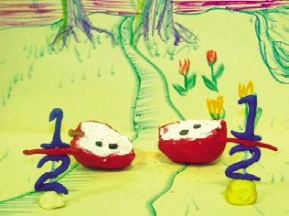
Step 3: Brainstorm and Plan
Steps for Students
Creating Animated Fractions in
Frames
™
Once
you
take
pictures
of
your
fractions object, you can use Frames
Fantastic
to
combine
them
into
a
Fraction animation.
1
.

Connect
your
camera
to
the
computer.
2
. Launch Frames.
3
.

Click the Library button to navigate
to
the
camera
and
import
the
frames you have captured.
4
.

Click and drag the pictures in the
storyboard to change the order.
.
5

Click the New blank frame button
on the toolbar to add more frames.
6
.

Text
Click
the
tool
on
the
Tools
panel to add text. Use the handles
and Format options to change how
the text looks.
7
.

Click the Record tool on the Tools
panel to add narration.
8
.

Select a frame or group of frames
the
Duration
slider
on
and
adjust
the
Tools
panel
to
change
the
timing.
9
.

Click the Save button on the toolbar
to save changes.
10
.

Click
the
Project
button
and
choose
Export
to
create
an
animated movie to share.

Divide students into small groups of 3–5. Have student teams choose a common object from the list that the class brainstormed. Student teams should choose the object that they think will best help other kids learn about fractions.
Have students complete a print storyboard before beginning to build their animations. Their storyboards should demonstrate how they will show the object as a whole, how it will be divided into fractions, and how these fractional parts will be labeled. This will help you evaluate for comprehension before they begin working.
Step 4: Build the Objects and Create an Animation
When the storyboards are complete, provide clay and other materials for the students to create the object they will divide into fractions, as well as a background or any other props their animations will need.
Each team should take between 15 and 40 still pictures of their objects dividing into various fractions.
On the computer, students can use Frames to combine the still images into an animation. Be sure to have them create a title screen, label the different fractions, and add their names to a credits page.
If students finish a basic animation early, have them write a School House Rock style song to go with their fraction animations. You might suggest a rapstyle song, with lyrics that rhyme.
Step 5: Share the Animations When students are finished creating their animations, celebrate their success by having each team present its animations to the rest of the class or to another class learning fractions. As they present, ask team members to share what they learned about fractions as they built their animations. You may also want to share the completed animations on your web site or during school video announcements. You could also give copies of the animation to your local access television station to help young television viewers learn this important math concept!

Assessment
Begin assessing student understanding as you work with manipulatives and explore fractions. See how many fraction ideas students come up with on their own, with family help, and then create a class list of objects.
The objects students choose can indicate comfort with the topic. Are they choosing only objects you have already worked with? Is everyone in the group comfortable with the choice? You may want to have them write an argument about why they think a given object will be the best way to teach someone else about fractions.
Be sure to check the storyboards before students begin taking pictures. This allows you to correct any misconceptions before the project proceeds too far.
As students present the final animation, ask each team member for feedback about the process and what he or she learned during it.

Antifaiff, Gloria. (April, 2000) Integrating Technology into the Curriculum.
Antifaiff, Gloria.
Antifaiff, Gloria
OSAPAC (2008) Resources. ”Clicker 5.28”. Retrieved from http://www.osapac.org/db/view_software.php?id=465
Special Education Technology-British Columbia (2011). “KWL Chart”. The Learning Centre. Retrieved February 15th, 2013, from http://www.setbc.org/setbc/curriculum/clickguidelearn.html.
Special Education Technology-British Columbia (2011). “Talking Book”. The Learning Centre. Retrieved February 15th, 2013, from http://www.setbc.org/Download/LearningCentre/curriculum/7_TalkingBook_New.pdf.
OSAPAC (2008) Resources. ”Frames 5”. Retrieved from http://www.osapac.org/db/view_software.php?id=485
Tech4Learning (n.d.) Create a Video Poem. In Creative Educators. Retrieved February 15th, 2013, from http://creativeeducator.tech4learning.com/v02/lessons/Create_a_Video_Poem.
Tech4Learning (n.d.) Fantastic Fractions. In Creative Educators. Retrieved February 15th, 2013, from http://creativeeducator.tech4learning.com/v04/lessons/Fantastic_Fractions.

