Ways to use Skype in the Classroom
When thinking of Skype, most people consider it to be a social networking tool used to communicate with friends and family living far away. Rather than rack up phone bills, Skype is a cheaper more personal communication tool. However, after discussing the benefits of using Skype in the classroom and visiting a variety of websites, our group came up with a few practical suggestions.
Firstly, Skype is an excellent tool for promoting communication among classes and schools around the world. Skype can be used among classes to debate about a social justice issue, learn about various cultures and traditions, as well as to develop an informal relationship. Skype can be used as an epal system, replacing traditional pen pals.
Skype can also be used to enhance communication outside of school between students, teachers and parents. Teachers can hold parent/teacher interviews using Skype in order to meet the demanding schedules of all parties involved. It can also be used as a tutoring platform where students can share their ideas, answer each other’s question and support each other in the learning process. Students can also use Skype to collaborate with each other on a group project, especially when one member of the group is away sick or on an extended vacation. Similarly, teachers can communicate, collaborate and participate in professional development sessions through Skype.
Skype can also be used to connect classes with people and professionals from various communities. Students can interview important figures in their community and from around the world using Skype, as well as follow the presentation of guest lecturers. Teachers can invite notable people from within the community to deliver story time to primary classes and/or to discuss ways in which students can get involved in their community. Finally, students can use Skype to interview and learn about helpers in different types of communities around the world (e.g., fishermen living in coastal communities). Some older students might even use Skype to practice their interview skills for upcoming University entrance requirements or job interviews.
Resource:
http://www.onlinedegrees.org/50-creative-ways-to-use-skype-in-your-classroom/
Staff Writers, “Online Degress.” (August 2012)

Collaborate with a peer from a different location on the same project.
2. For secondary students to practice their interview skills for a University Program or job oppoturnity.
3. To explore other schools and communities around the world to learn about their culture and traditions.
4. To debate with other classes about social justice issues.
5. To interview and learn about helpers in different types of communities (e.g., fishermen living in coastal communities)
6. Parent teacher conferencing can be done on skype to replace traditional interviews.
7. Students can offer peer tutoring through skype.
8. Guest lectures can deliver their presentation on Skype.
9. Professional Development sessions for staff can be offered on Skype.
10. Storytime can be presented on Skype by notable people in the community.
11. Use Skype to develop an epal relationship with schools around the world.
12.

Adobe Connect
Overview
Adobe Connect is a multimedia, web conferencing tool. Users can use the web tool for web meetings, conferences, eLearning sessions, as well as webinars. Adobe Connect allows users to interact with others with in their session on any device, through the use of video, text (e.g., chat), as well as audio, all without having to download the software on to your device. There are many ways to interact with others using the tool:
- screen-sharing between a host and his/her audience members--all members can interact with the presenter through multimedia;
- web conferencing--all members are virtually present and can interact with those in other sessions;
- real-time collaboration--multiple users can present, revise, edit, and re-present documents in real-time while being virtually present;
- present pre-recorded media within a live session--session members can present multimedia projects for discussion and/or critique amongst other users in real-time;
- participate in a debate, live discussion, or question period with a host(s)--users can interact with a host and receive feedback in real-time.

Ways to use Adobe Connect in the classroom:
Adobe Connect is a rich, web tool which has the capacity to replace the traditional classroom with a virtual one. Almost all facets of the classroom can be imitated online with Adobe Connect--even the ability to raise your hand!).
Figure 1http://www.adobe.com/products/adobeconnect/features.html
2http://www.adobe.com/products/adobeconnect/features.html

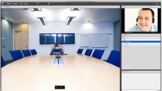
One way to utilize Adobe Connect in the classroom is to have students or groups of students give a presentation to his/her classmates online. The presenter(s) can host the presentation and present the information--a slideshow about Jacques Cartier--to his/her classmates, while his/her audience participated with a headset and microphone, asking oral questions for clarity, or providing feedback in the form of text. The entire session can be interested parent--and posted on the classroom's website or blog.

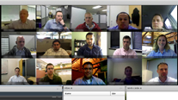
A second way to utilize Adobe Connect in the classroom is to host a debate on a social justice issue. For instance, a class could participate in an online debate concerning the loss of habitat in their community. The entire class could be virtually present with a headset while the issue was debated. The tool is really effective in a debate because students can prepare ahead of time rebuttal information in many different forms, such as an Excel spreadsheet, a slideshow, a Youtube video, as well as any of a variety of other media, and present it as their defence. Or, students can retrieve the information in real-time, while their opposition is providing details, and share it in screencasting mode.
3http://www.adobe.com/products/adobeconnect/features.html

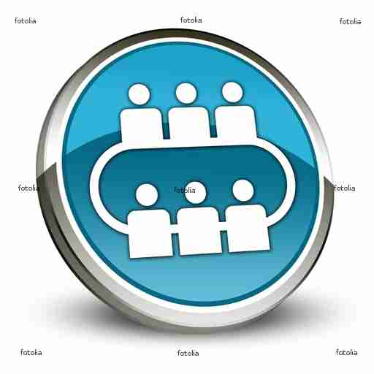
A third way to utilize Adobe Connect in the classroom is by having a special guest/expert in a field of study or professional present a presentation in which students can ask questions or interact with the presenter, virtually. A local or global personality, such as a geologist, could provide students with information about the types of rocks in the area. He/She could have specimens as well as diagrams, charts, multimedia content, etc., to help enrich the presentation. Students could interact with the presenter by asking oral questions and/or providing their own learning to receive feedback from the expert.
4fotolia.com

A fourth way to utilize Adobe Connect in the classroom is by hosting lectures online. Students could participate in a teacher-driven lecture on a specific topic--the medieval feudal system. The teacher could present a prepared presentation with multimedia, while students participated as an audience, virtually with a headset. When finished, the class could have a discussion and/or question period about the topic. The entire session could then be saved and presented again for those who were absent.
5fotolia.com

A fifth way to integrate Adobe Connect in the classroom is by hosting a literature circle. Students reading a shared novel could discuss each chapter's events and/or characters online. The discussions could be saved and the teacher could view them afterward to assess and provide feedback on their progress.
6fotolia.com

Parents and teachers could also connect to touch base on a child's success at school. With pre-recorded and digital documentation, the teacher could simply upload and share the student's work in real-time with his/her parents, having face-to-face contact, but not requiring both to be in the same room.

Feature | Skype | Adobe Connect
- audio | Yes | Yes
- video | Yes | Yes
- audio conferencing | Yes (up to___) | Yes (up to ___)
- video conferencing | Yes (up to 8) | Yes (up to 15)
Comparing Skype & Adobe Connect

